CSIT314 Software Development Methodologies - Group Project

Sprint 2 - US12: Search user account
Interior Design Platform - User Admin
All diagrams were drawn in draw.io. Open "US12 Search user account.drawio" in this folder to edit them - each diagram is its own page in that file. The exported images are in the "diagrams" folder.

Assumptions
- The system is the Interior Design Platform from the project specification. Sprint 2 covers the User Admin's search user profiles story (US7) and managing user accounts (US8 - US12).
- A user account is one person's login. It has a username, password, full name, email, phone, the user profile (group) it belongs to, a status (Active or Suspended) and the date it was created. Every account belongs to exactly one user profile and gets that profile's permissions.
- We follow B-C-E: the actor only talks to the boundary (page), the boundary only talks to the controller, and the controller works with the entity classes. There is one controller per use case.
- Simple input checks (empty fields) are done in the boundary. Business rules (e.g. unique usernames, active profile) are done in the controller. Entity classes read and write the database.
- The search checks the account's username, full name and email for the keyword. Capital letters don't matter, and spaces around the keyword are ignored.
- If the keyword is empty, all the accounts are shown.
- Suspended accounts still show up in the results (with their status), because the admin might still need to find them.
- Searching doesn't change any data.

1. User story
Story ID | US12
User story | As a user admin, I want to search for user accounts so that I can find the user I need to manage.
Actor | User Admin
Priority | Medium
Story points (estimate) | 2
Acceptance criteria | 1. Given I am on the User Accounts page, there is a search box and a "Search" button.  2. Given I type part of a username, full name or email and click "Search", then I see every account that matches, with its status.  3. Capital letters don't matter (e.g. "chloe" finds "Chloe Ng").  4. Given the keyword is empty, then all accounts are shown.  5. Given nothing matches, then I see "No user accounts found".  6. Suspended accounts are included in the results.
Tasks | T12.1 Write the use case description and draw the use case diagram  T12.2 Draw the B-C-E class diagram and the sequence diagram  T12.3 Draw the wireframes for the search box, the results and the "no results" message  T12.4 Write the unit tests first (TDD) for UserAccount.searchUserAccounts() and SearchUserAccountController  T12.5 Code UserAccount.searchUserAccounts()  T12.6 Code SearchUserAccountController  T12.7 Code SearchUserAccountPage: search box, results list and "no results" message  T12.8 Link each result to View user account (US9)  T12.9 Run the test cases, fix bugs and push to the repo so the CI pipeline runs the unit tests

2. Use case diagram
The user story becomes one use case, UC12 Search user account. The User Admin is the only actor.
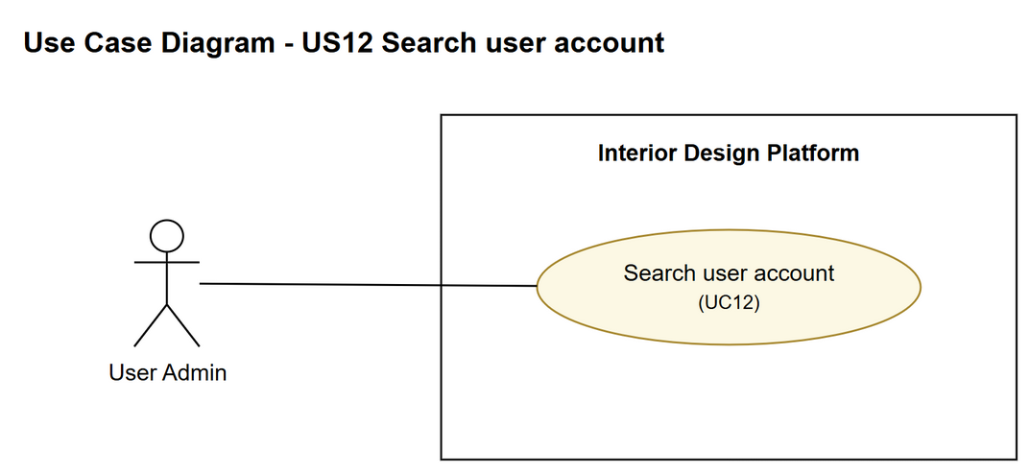
Figure 1: Use case diagram for US12 Search user account

3. Use case description
Use case | UC12 Search user account
Actor | User Admin
Brief description | The User Admin searches the user accounts by keyword to find the user they need to manage.
User story | US12: As a user admin, I want to search for user accounts so that I can find the user I need to manage.
Preconditions | The User Admin is logged in (UC1).
Trigger | The User Admin types a keyword into the search box on the User Accounts page and clicks "Search".
Basic flow | 1. The User Admin types a keyword (e.g. part of a username or name) and clicks "Search".  2. The system looks through all the user accounts for ones with the keyword in their username, full name or email.  3. The system shows a list of the matching accounts, with each one's username, full name, email and status.  4. The User Admin picks the account they want to manage. From here they can view, update or suspend it, but those are separate use cases.
Alternative flows | 1a. If the keyword is left empty, the system just shows all the user accounts.  3a. If nothing matches, the system shows "No user accounts found" and the User Admin can try a different keyword (back to step 1).
Postconditions | Nothing in the system is changed.

4. Wireframes
The wireframes were drawn in draw.io. They are low-fidelity: they show the layout and the flow, not the final colours. The orange numbers match the notes under each screen.

4a - Search results
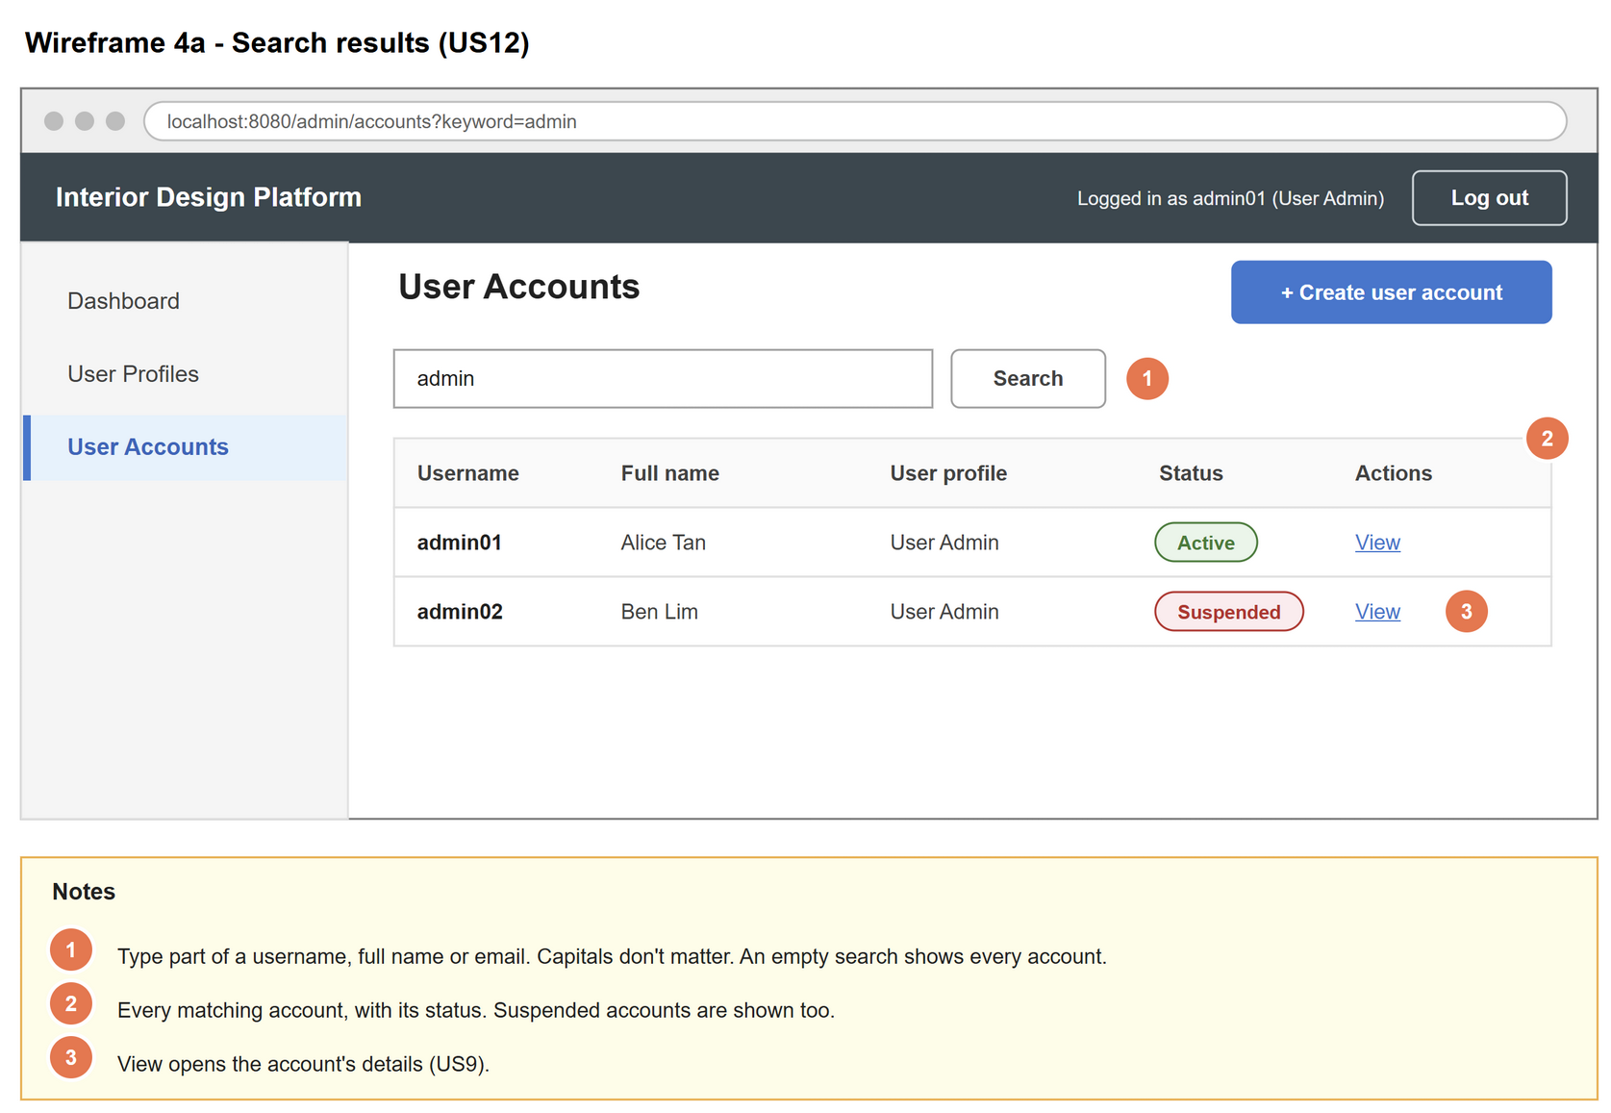
Figure 2: Wireframe 4a - Search results (US12)

4b - No results
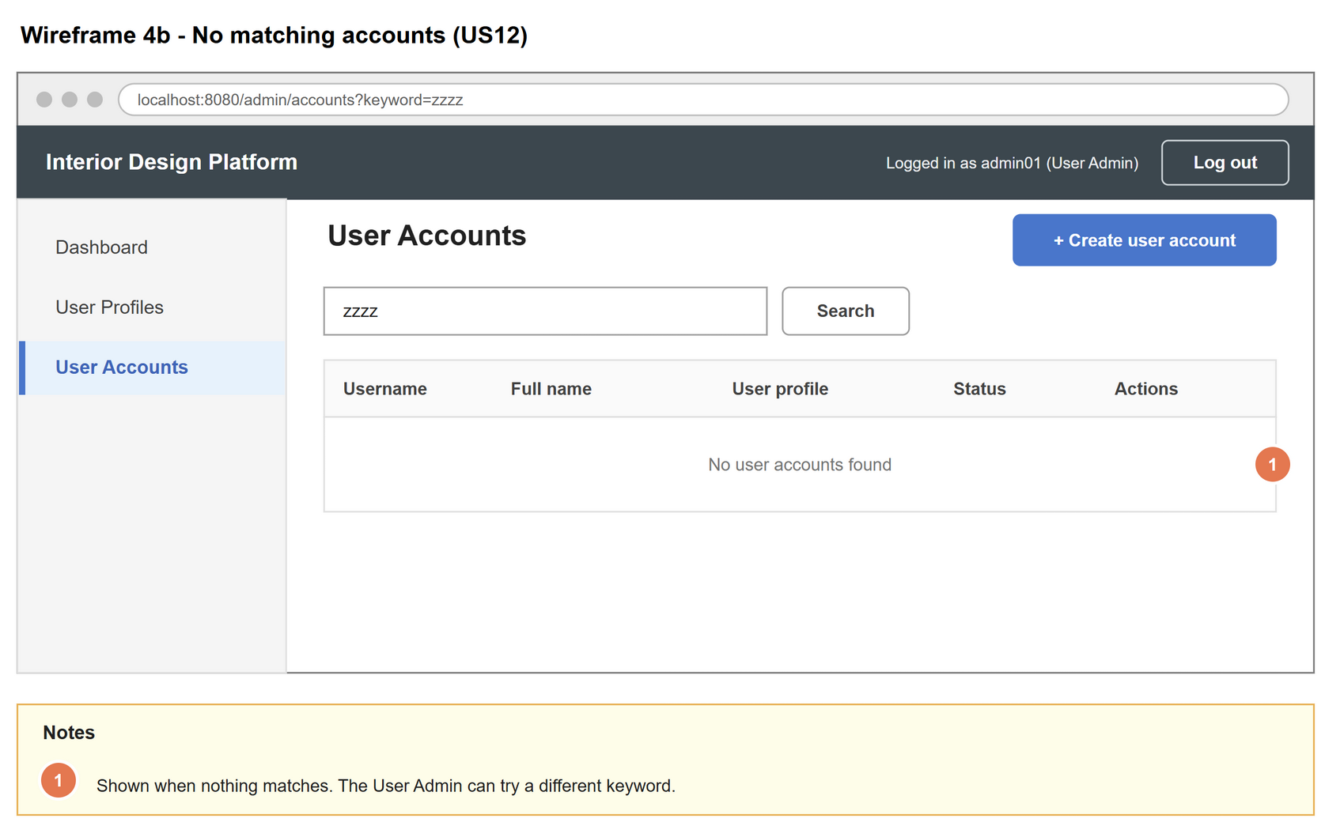
Figure 3: Wireframe 4b - No results (US12)

5. B-C-E class diagram
The solid line means the boundary calls the controller. The dashed line means the controller uses the entity class. Only the operations needed for this use case are shown.
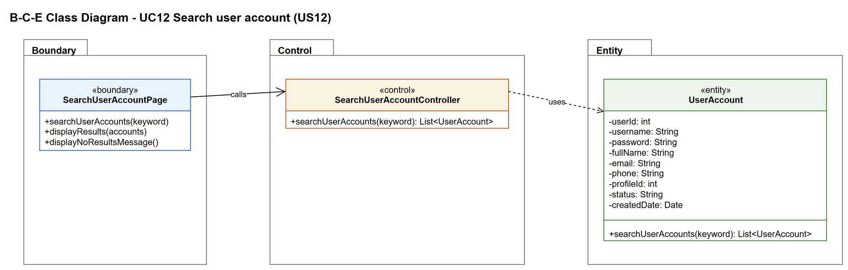
Figure 4: B-C-E class diagram for US12 Search user account
Layer | Class | What it does
Boundary | SearchUserAccountPage | The search box and results list. Gets the keyword from the User Admin, then shows either the results or the "No user accounts found" message.
Control | SearchUserAccountController | Controller for UC12. Takes the keyword from the page, passes it to UserAccount, and sends the list of matches back to the page.
Entity | UserAccount | searchUserAccounts() finds the saved accounts that match the keyword and returns them as a list.

6. Sequence diagram
The sequence diagram follows UC12. The keyword goes from the page to the controller to UserAccount, and the list of matching accounts comes back (steps 1 to 3). The alt box shows the two ways it can end: matching accounts are found and shown (basic flow), or nothing matches and a message is shown instead (alternative flow 3a).
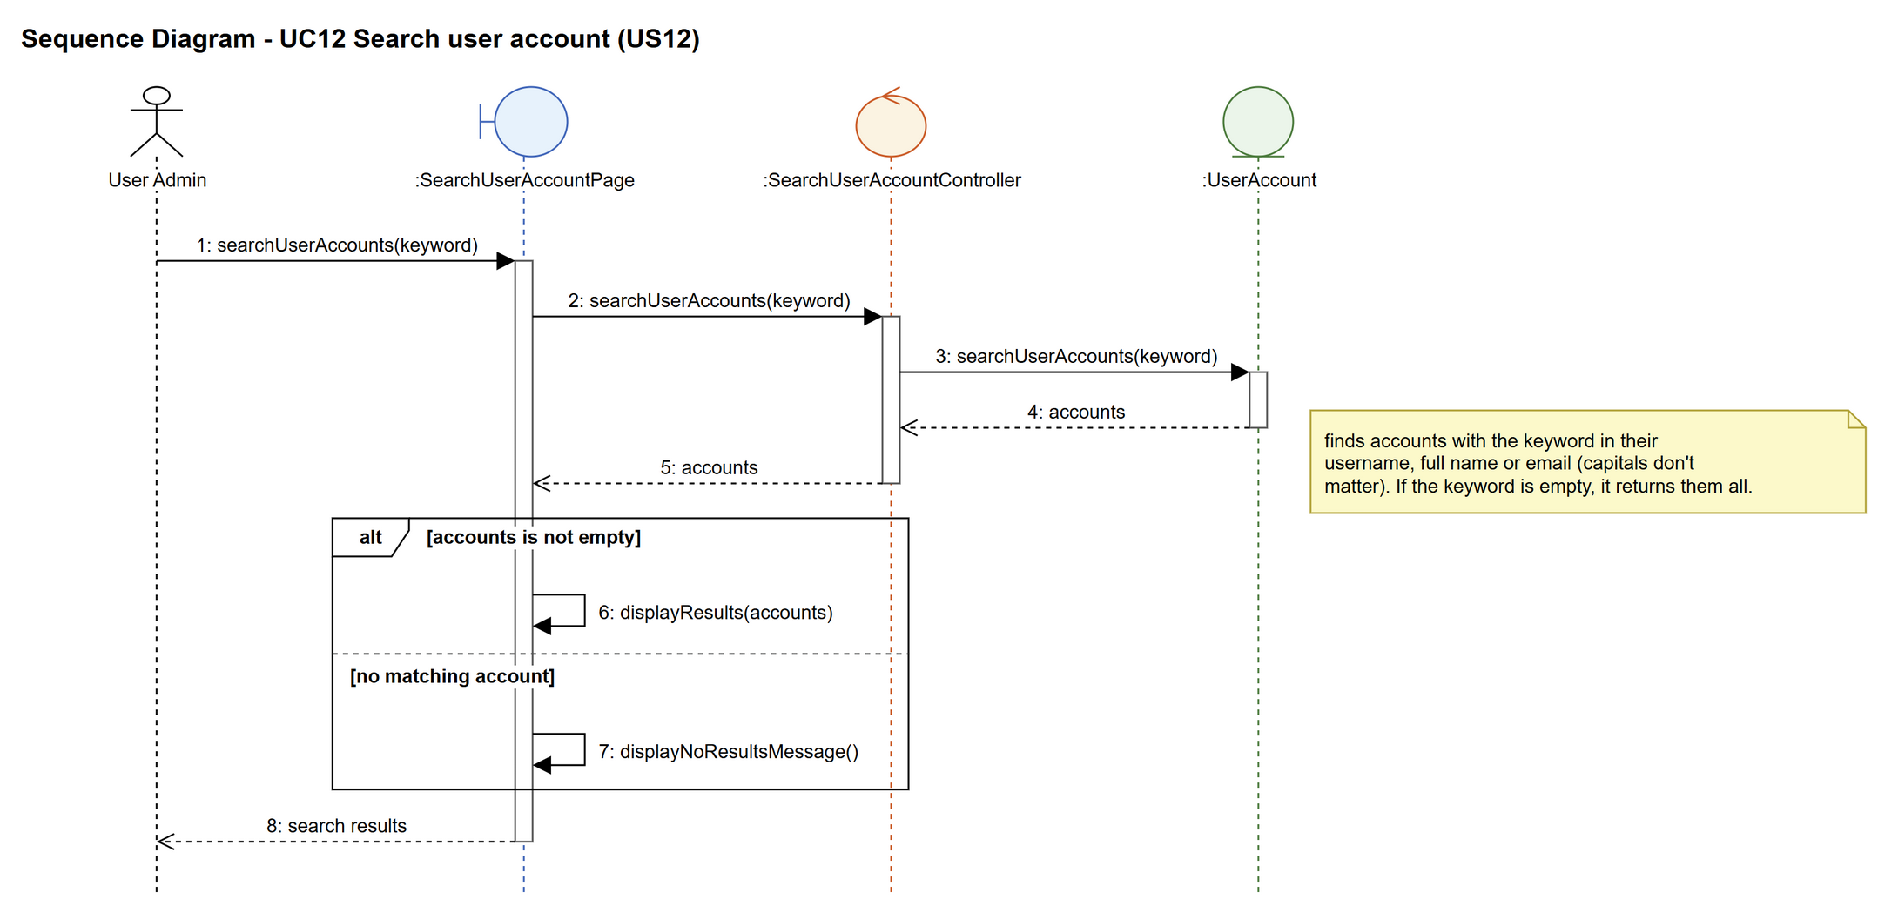
Figure 5: Sequence diagram for UC12 Search user account

7. Test cases
Test data used below (same as database/seedData.py): user profiles User Admin (id 1), Interior Designer (id 2), Customer (id 3) and Platform Manager (id 4), all Active. User accounts admin01 / Admin@123 (id 1, User Admin, Active), admin02 / Admin@123 (id 2, User Admin, Suspended) and cust001 / Cust@123 (id 3, Customer, Active).

7a. System test cases (black box)
Equivalence partitioning and boundary value analysis were used to pick the test data. Fill in "Actual result" and "Pass/Fail" after running each test.
Test ID | Scenario | Prerequisites | Test steps | Test data | Expected result | Actual result | Pass / Fail
TC12.1 | Search by username | Logged in as admin01. | 1. Type the keyword  2. Click "Search" | admin01 | admin01 is in the results, with its status.
TC12.2 | Search by full name | Logged in as admin01. | 1. Type the keyword  2. Click "Search" | Chloe | cust001 (Chloe Ng) is in the results.
TC12.3 | Capitals don't matter | Logged in as admin01. | 1. Type the keyword  2. Click "Search" | CHLOE | Same result as TC12.2.
TC12.4 | Search by email | Logged in as admin01. | 1. Type the keyword  2. Click "Search" | cust001@archss | cust001 is in the results.
TC12.5 | Suspended accounts are shown | Logged in as admin01. | 1. Type the keyword  2. Click "Search" | Ben | admin02 (Ben Lim) is in the results with status Suspended.
TC12.6 | Empty keyword | Logged in as admin01. | 1. Leave the search box empty  2. Click "Search" | (empty) | All user accounts are shown.
TC12.7 | No match | Logged in as admin01. | 1. Type the keyword  2. Click "Search" | zzzz | "No user accounts found".

7b. Unit test cases (for TDD)
These are written before the code (test-driven development) and run automatically in the CI pipeline. They cover normal inputs, abnormal inputs and boundary values.
Test ID | Class and method | Input / setup | Expected output | Type | Pass / Fail
UT12.1 | SearchUserAccountController.searchUserAccounts() | "admin0" | Returns 2 accounts: admin01 and admin02 | Normal
UT12.2 | SearchUserAccountController.searchUserAccounts() | "CHLOE" | Returns 1 account: cust001 | Normal
UT12.3 | SearchUserAccountController.searchUserAccounts() | "" | Returns all 3 accounts | Boundary
UT12.4 | SearchUserAccountController.searchUserAccounts() | "zzzz" | Returns an empty list | Abnormal
UT12.5 | SearchUserAccountController.searchUserAccounts() | "Ben" | Returns admin02 with status "Suspended" | Normal
UT12.6 | SearchUserAccountController.searchUserAccounts() | " chloe " (spaces around it) | Returns cust001 (spaces are ignored) | Boundary
UT12.7 | UserAccount.searchUserAccounts() | "cust001@archss" | Returns cust001 | Normal

